Social Media Toolkit
Thank you for supporting the launch and sharing of our research into LGBTQ+ young people’s experiences of mental health support. Our key messages that we’d love for you to share in your messages are:
- This research was co-produced between queer and trans researchers at The Kite Trust and LGBTQ+ young people in Cambridgeshire and Peterborough.
- We found that journeys to accessing mental health support are long and complex, that there are barriers even before young people start looking for support, and that LGBTQ+ youth’s needs are not met by current services.
- We found that mental health service staff lack specific knowledge and understanding of LGBTQ+ identities and experiences, and young people face additional barriers around disability, neurodivergence, financial resources and race.
- LGBTQ+ young people have clear ideas about what good support looks like and wider networks including friends, family, youth workers and colleges play a key role is enabling access to mental health support.
- We need action that includes adequately resourcing mental health services, supporting young people to navigate them, adopting inclusive practices in services, and collaborative working to create an equitable mental health support system.
We have created a series of graphics sized for different social media platforms that you are welcome to use. Please include a link to the report in all your posts: https://bit.ly/lgbtqyouthreport and tag us @TheKiteTrust.
You can draft your own post, retweet posts from The Kite Trust, or use some of the templates below as a starting point.
- Check out @TheKiteTrust’s research & call to action to improve mental health support for LGBTQ+ youth. We need to better fund mental health services, support youth to navigate them, adopt LGBTQ+ inclusive practices, & collaborate. Read more: https://bit.ly/lgbtqyouthreport
- Journeys to accessing mental health support are long and complex, there are barriers even before you start looking for support, and LGBTQ+ youth’s needs are not met by current services. That's what @TheKiteTrust found in their recent research: https://bit.ly/lgbtqyouthreport
- Mental health service staff lack specific knowledge & understanding of LGBTQ+ identities & experiences, and young people face additional barriers around disability, neurodivergence, financial resources & race. @TheKiteTrust found in their recent research: https://bit.ly/lgbtqyouthreport
- LGBTQ+ young people have clear ideas about what good mental health support looks like, & wider networks including friends, family, youth workers and colleges play a key role is enabling access. That's what @TheKiteTrust found in their recent research: https://bit.ly/lgbtqyouthreport
- There should be #NothingAboutUsWithoutUs. That’s why @TheKiteTrust’s research is so important – co-produced by queer and trans researchers with LGBTQ+ youth in Cambs & Pboro. Read more: https://bit.ly/lgbtqyouthreport

Twitter images:
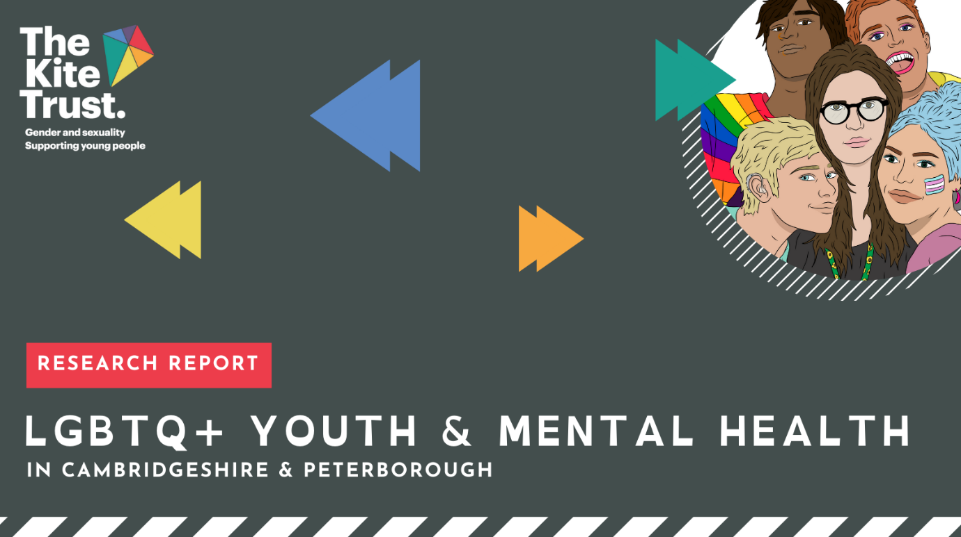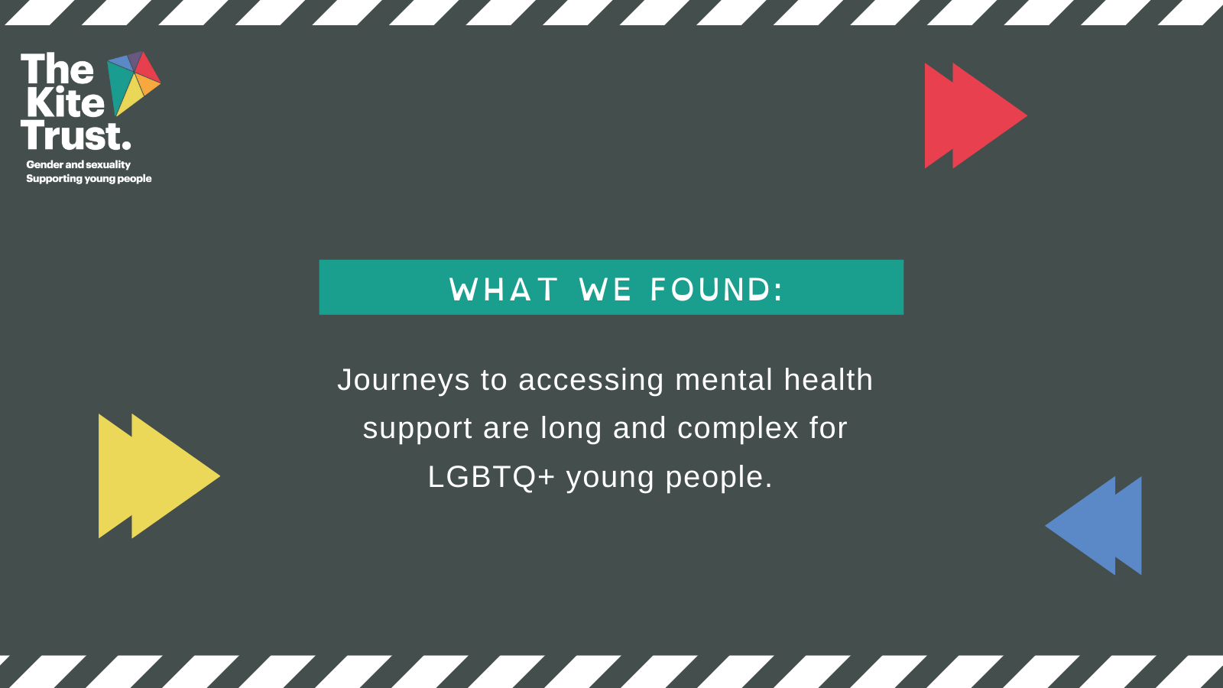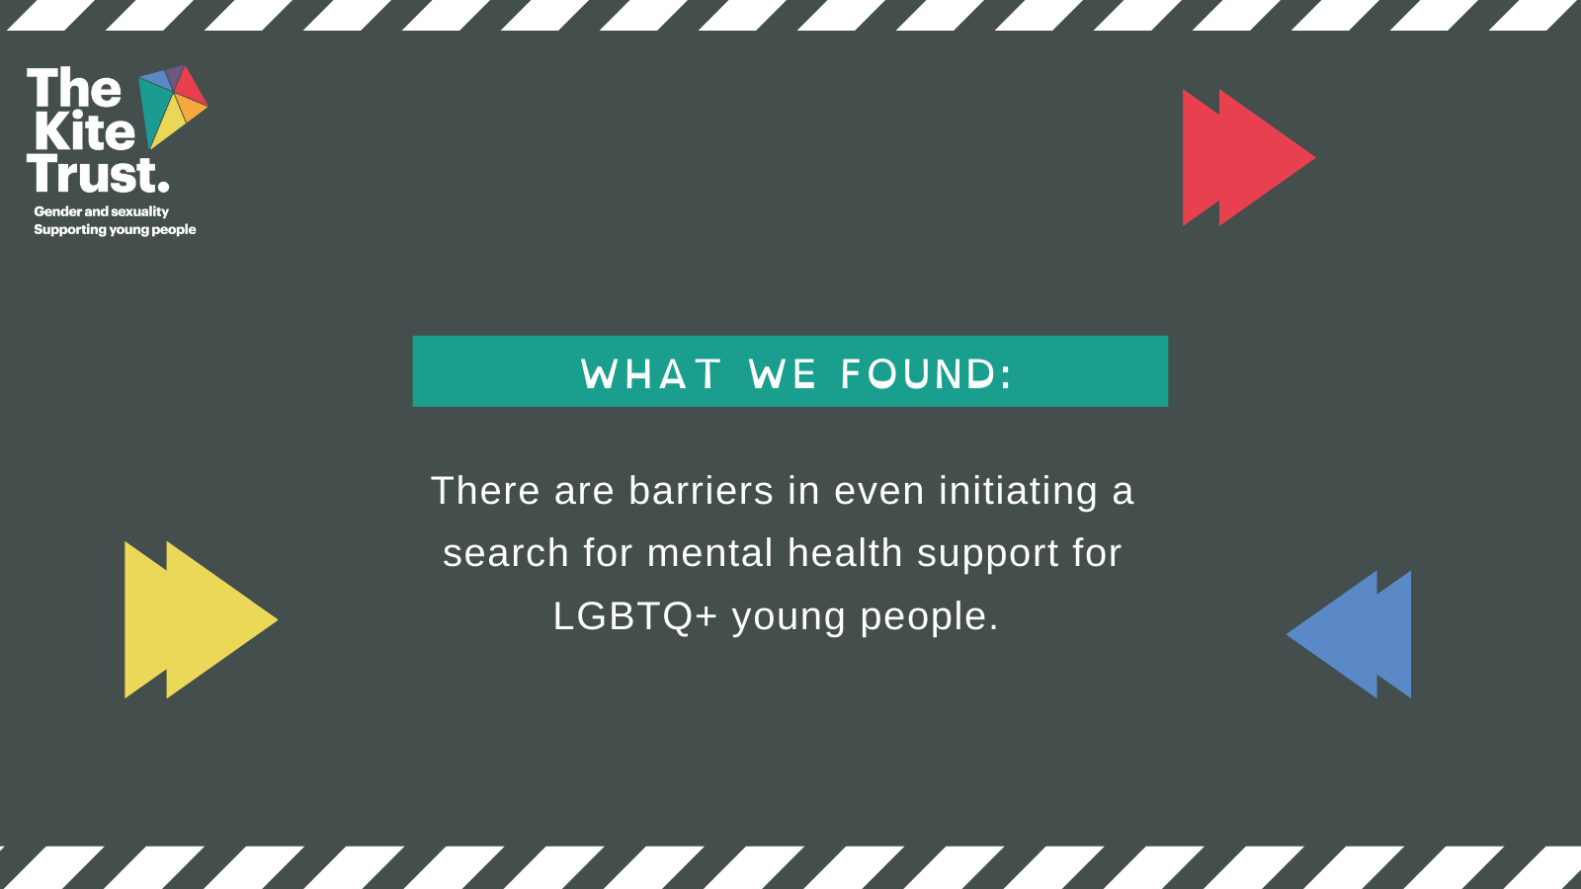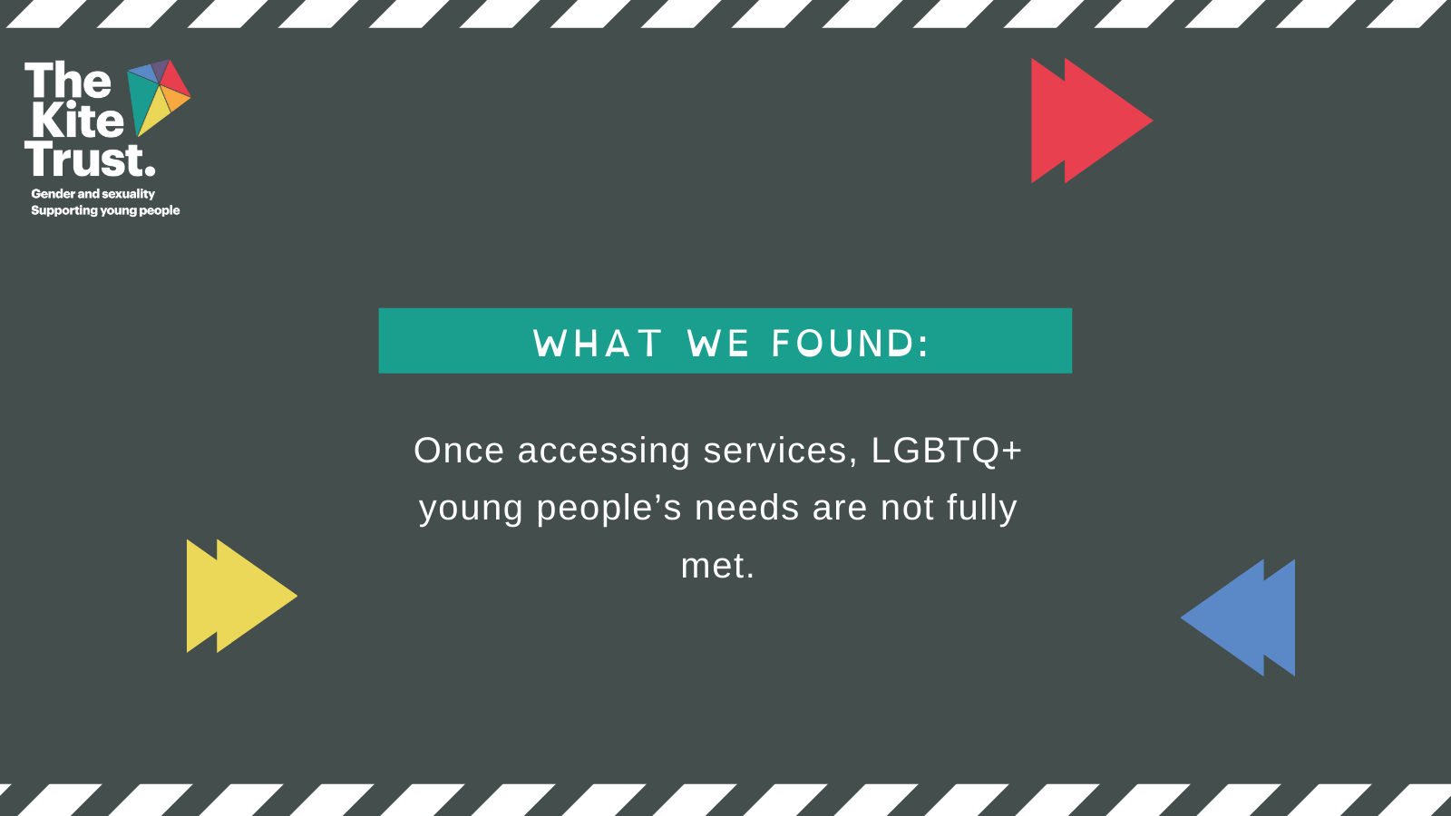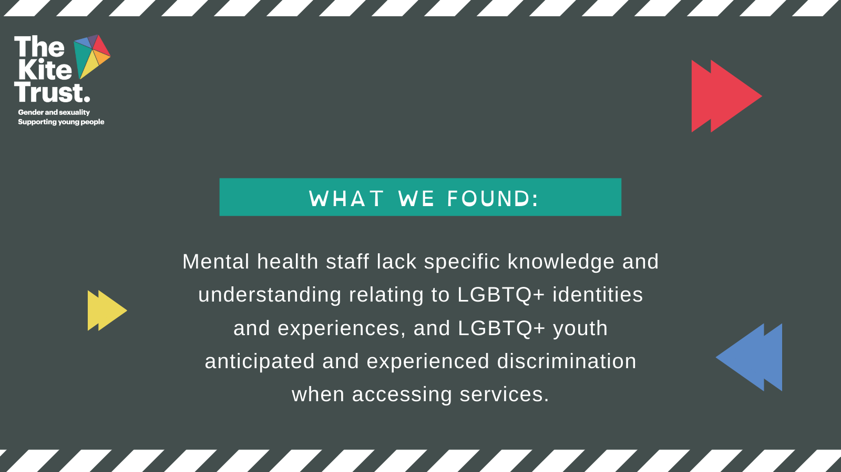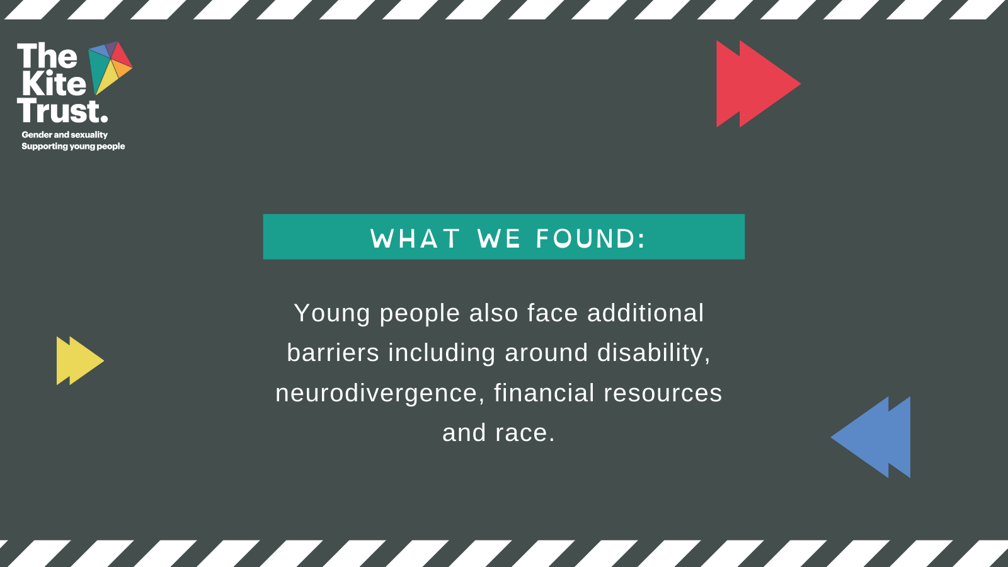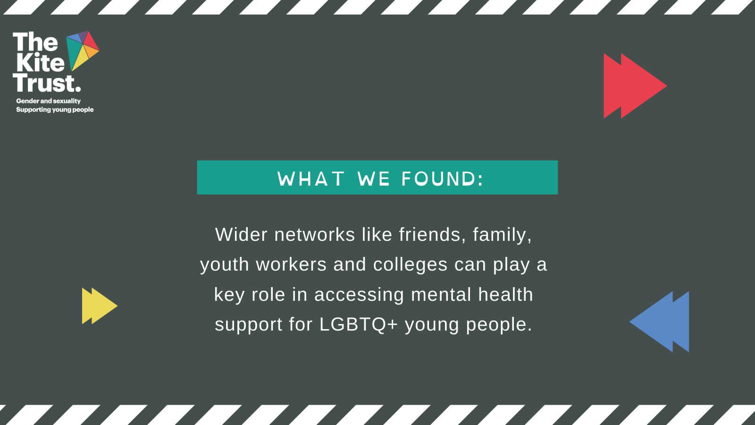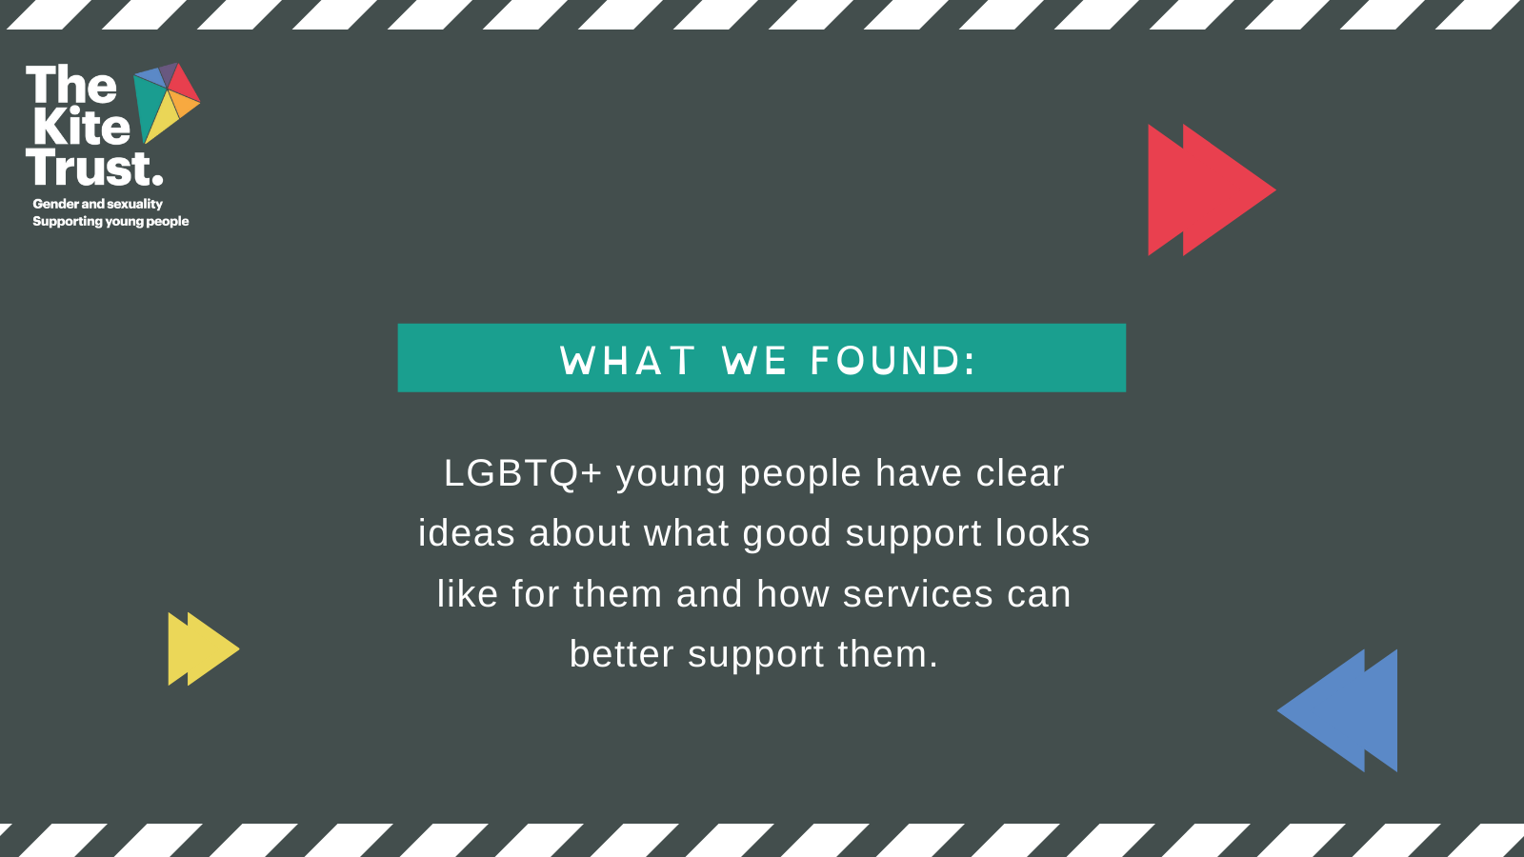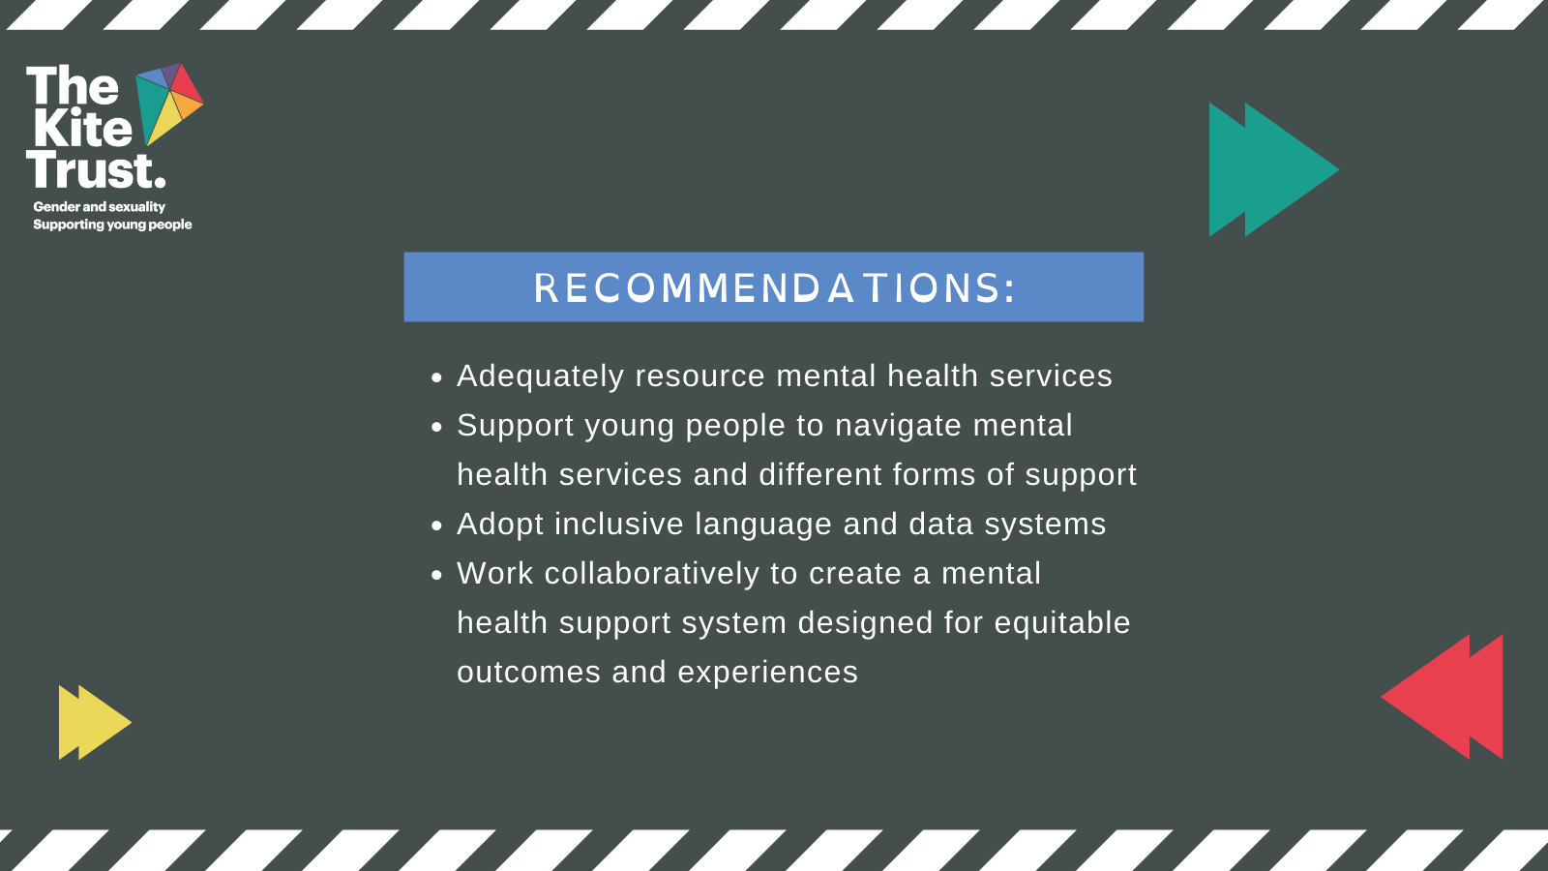

Instagram images:
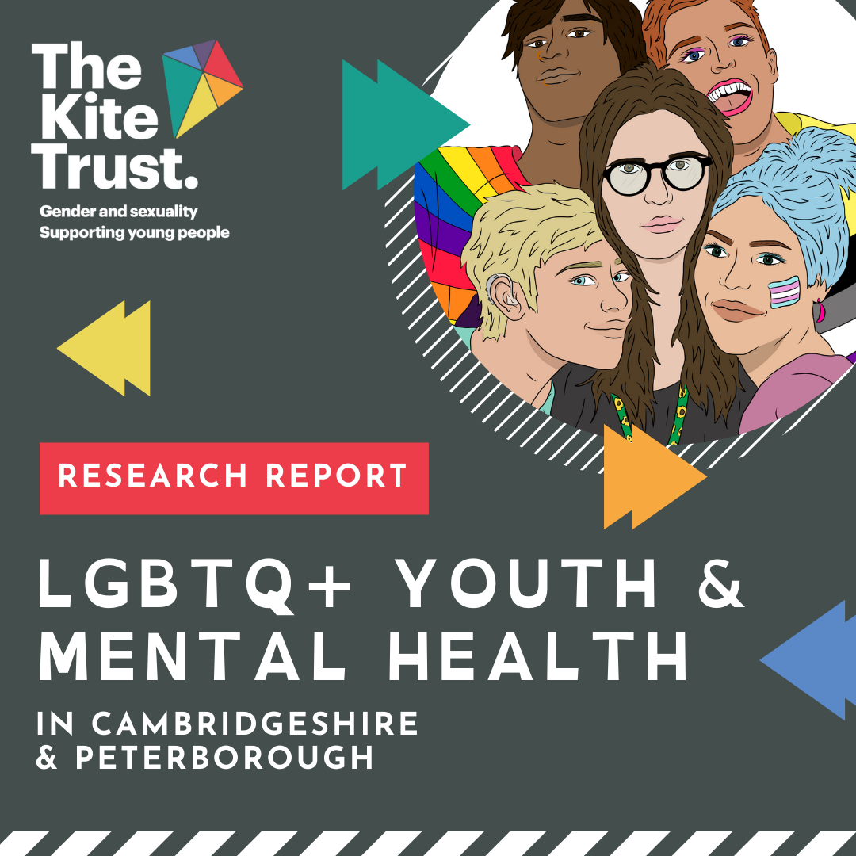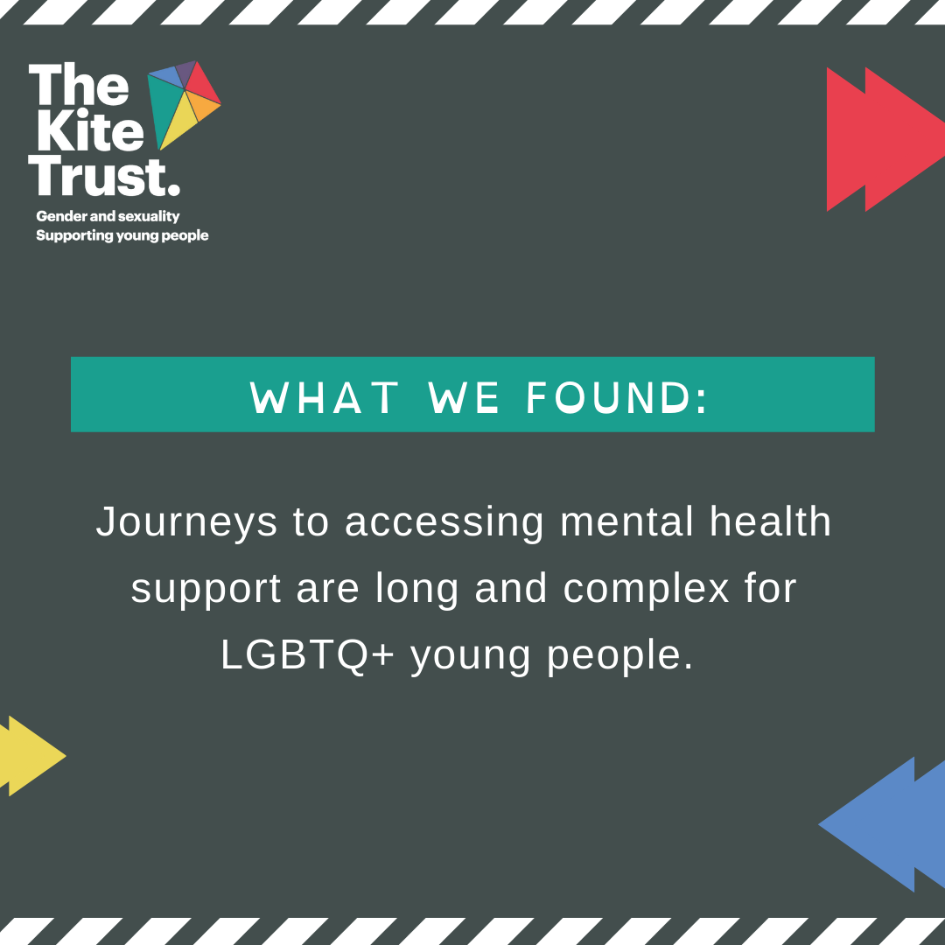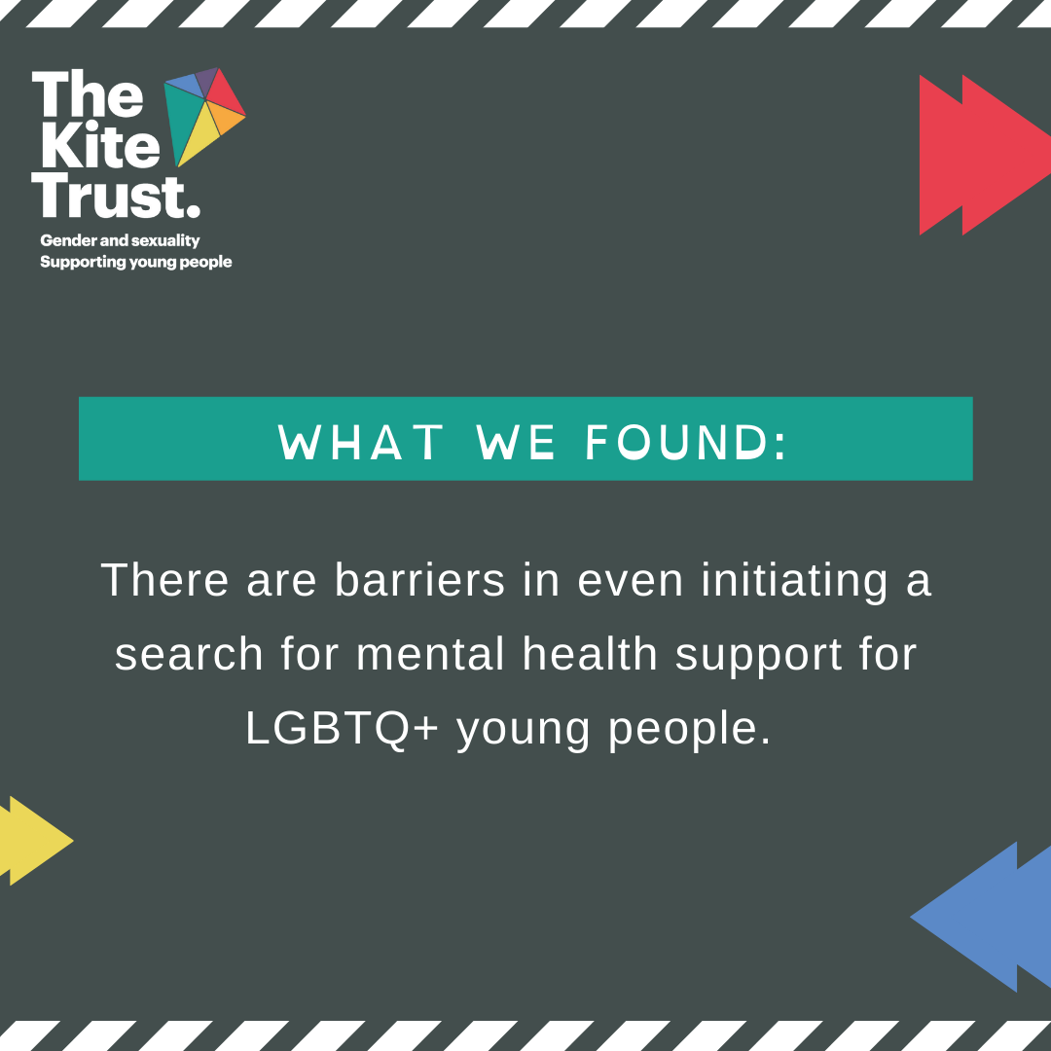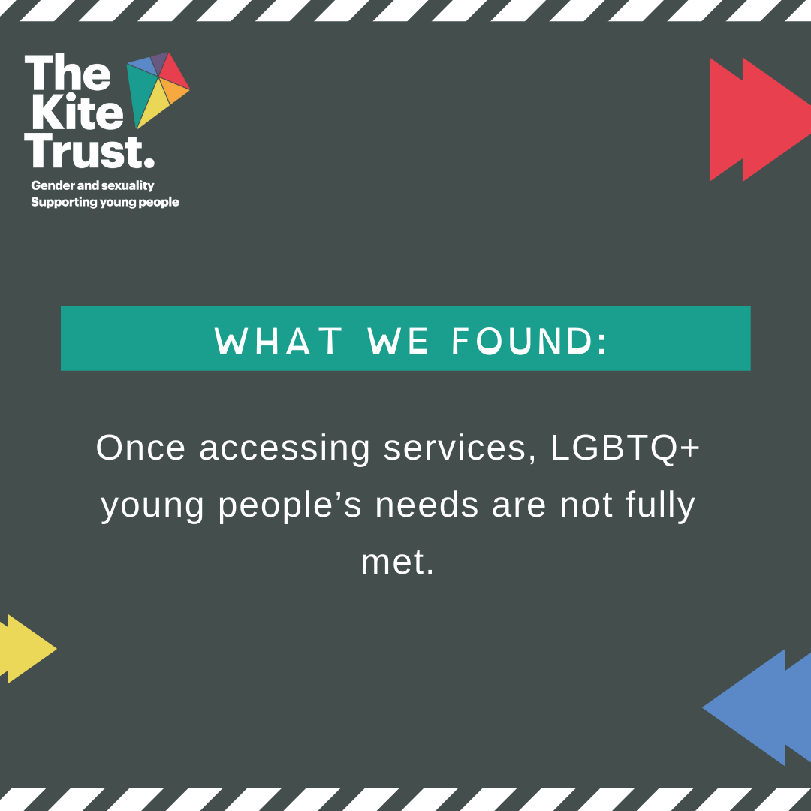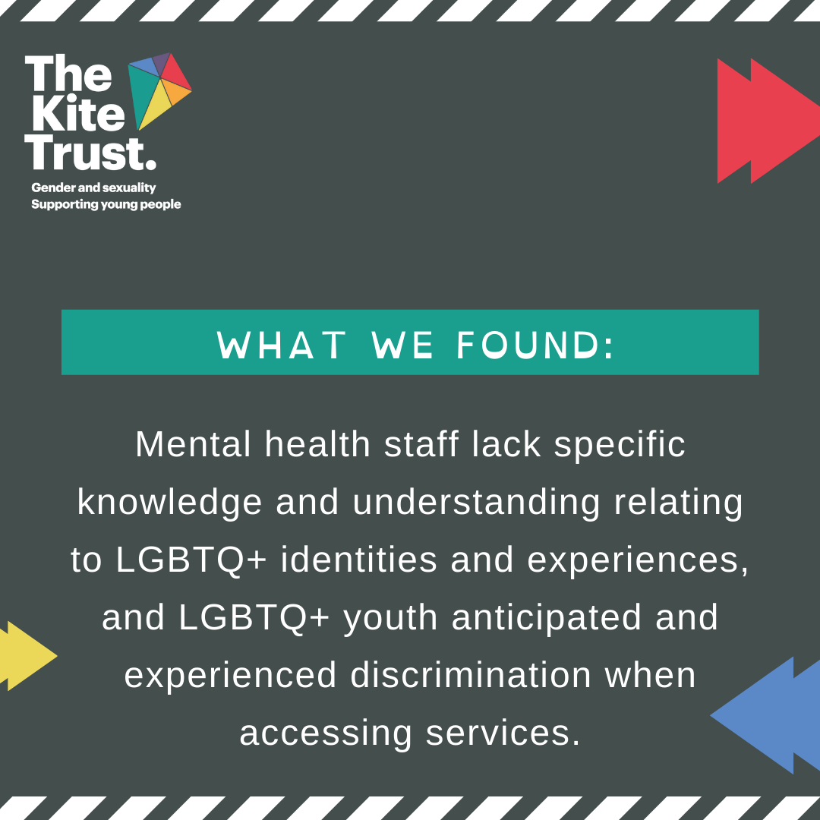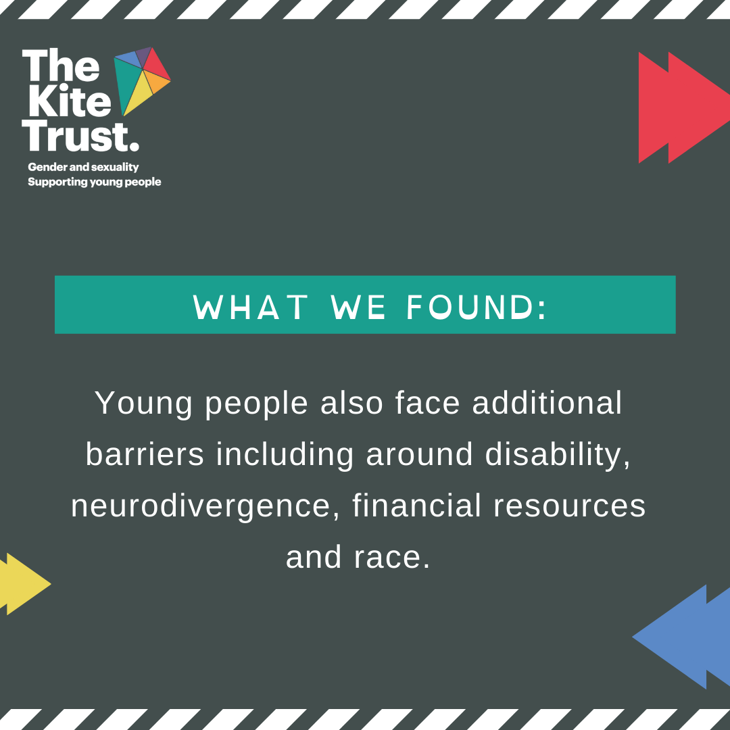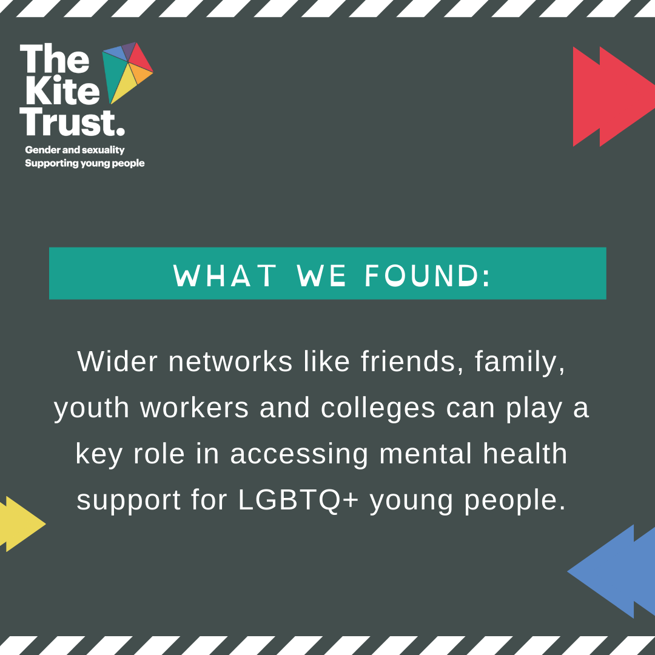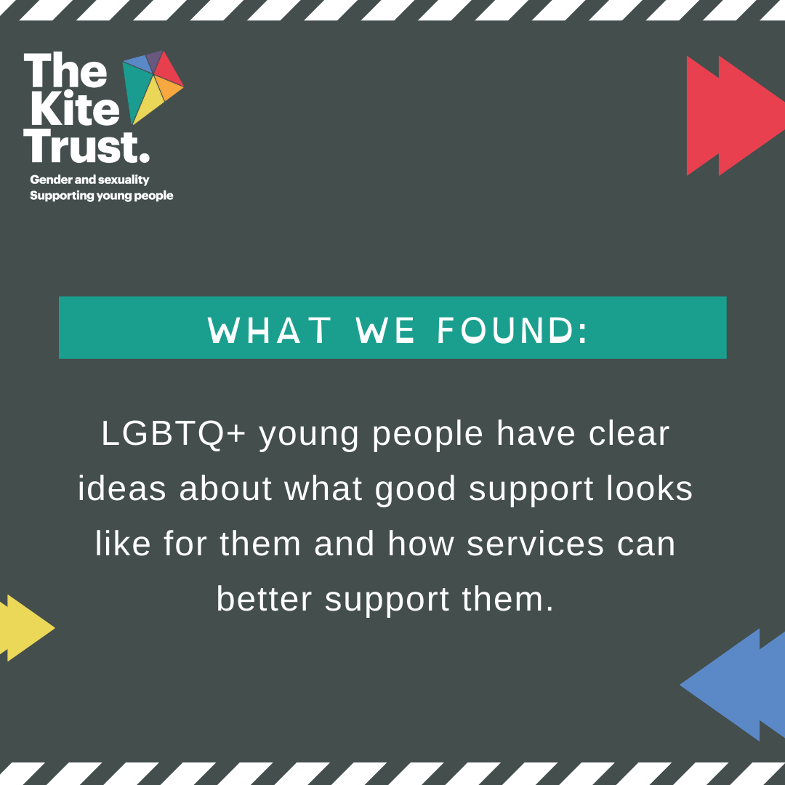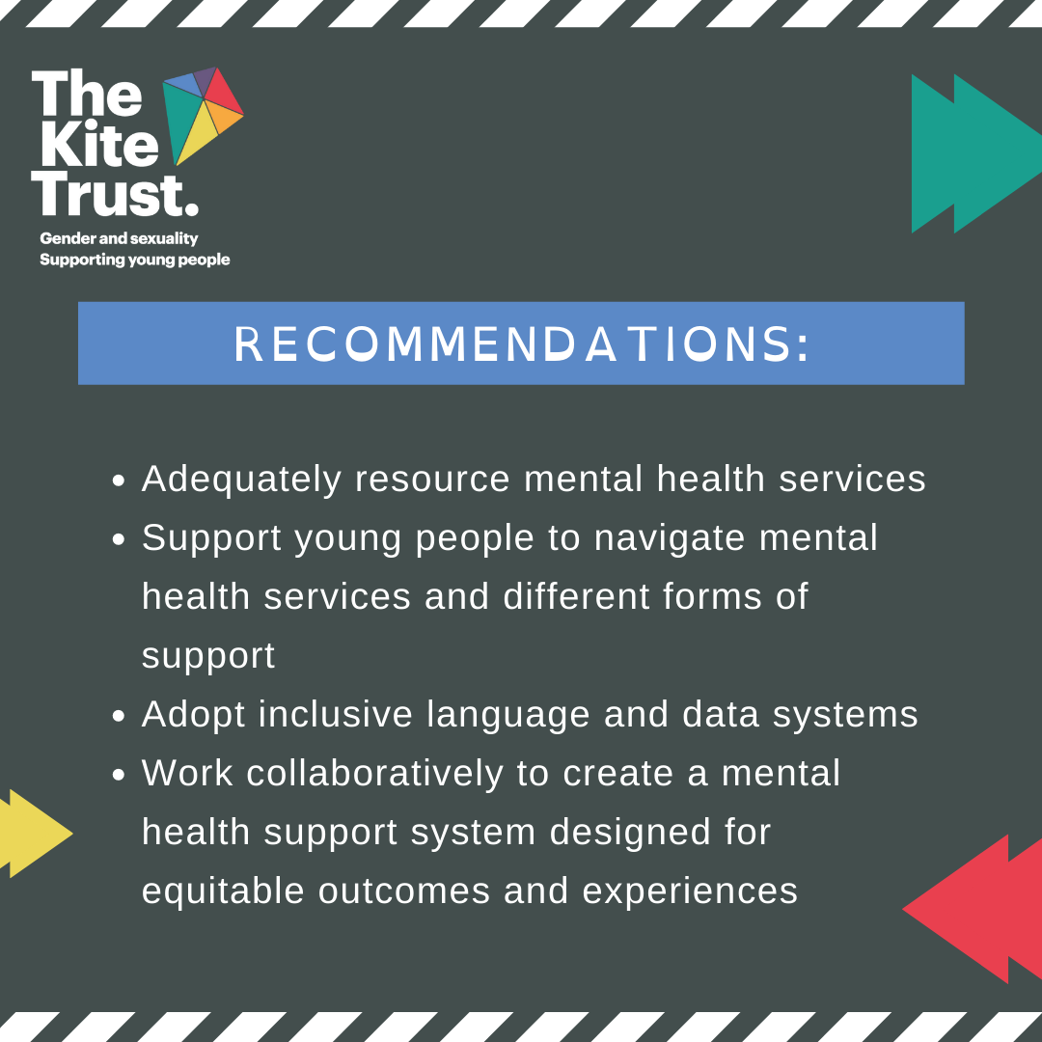

Facebook Images:
